Nati Levi // Photographer
E: nati.photography@gmail.com | M:+972-54-758-0883 | insta: Nati.Photograpy | FB: Nati Levi Outdoor Photography

Professional Summary
Stills photographer with more than 15 years of diverse experience, working as a freelance, and in the last year also as a partner at: ”Der Rote Drache Photography” (Germany team) who covering POLO events. Committed to deliver high quality results, according to costumer creative vision and requirements. Intimately familiar with different photography styles and environments. Extremely communicative, with excellent people skills.
Leading stills photographer backstage for a Netflix Israeli production, “FAUDA”.
Skills
Excellent communication with costumer pre and post production, as well as on-site, to proactively avoid errors and misunderstandings.
Experienced in different kinds of photography –Portrait, motor sports - rally events in Europe, Combat fitness training for special army units, TV and movie production (specialty in “making of” shootouts for crime and action genres), business and private events, and more. I was interviewed on the Israeli sports channel as a Rally photographer
Graphic design and post-editing skills - Design, editing and production of photo books for documenting events
Recent Work Samples

FAUDA – 2nd season directed by Rotem Shamir

ASSILUM SITY - TV Series, 1st season, directed by Eitan Tzur

HAMOSAD - Feature film, directed by Alon Gur Arie

PRESSED FOR WEDDING - Feature film, directed by Guri Alfi

THE MAGPIE - New TV Series, Crime Drama directed by Ariel Benbaji

FAUDA – 3rd season, directed by Rotem Shamir

DO NOT WAIT FOR ME - Feature film, directed by Danni Reisfeld

SHABAS - New TV Series

RON - 3rd season, TV Series directed by Ron Feldman

UNDERDOG - New TV Series
My photographic equipment:
- Canon 5D Mark III

EF 70–200mm f/4L IS II USM

24–105mm F4 L IS USM

Sigma art 35mm 1.4

Sigma 10-20mm F3.5 EX DC HSM
Computer software's in use:

Adobe Lightroom

Adobe Photoshop

Adobe InDesign

Adobe Illustrator

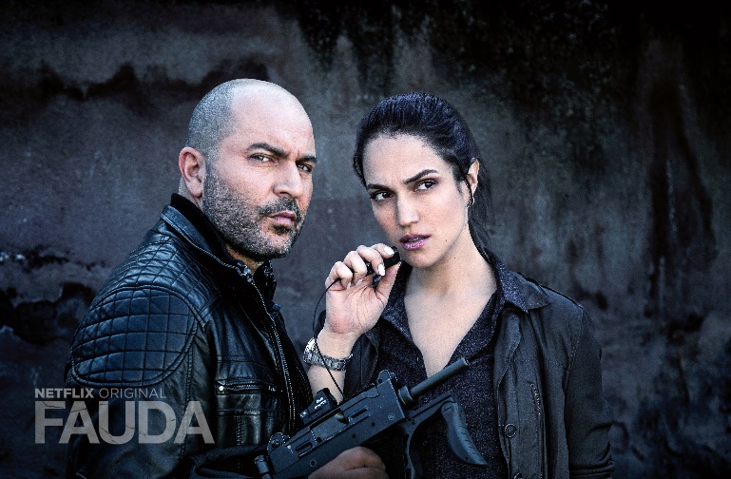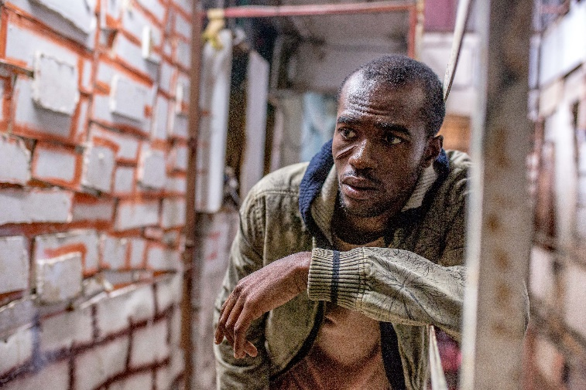

FAUDA – 2nd season directed by Rotem Shamir

ASSILUM SITY - TV Series, 1st season, directed by Eitan Tzur

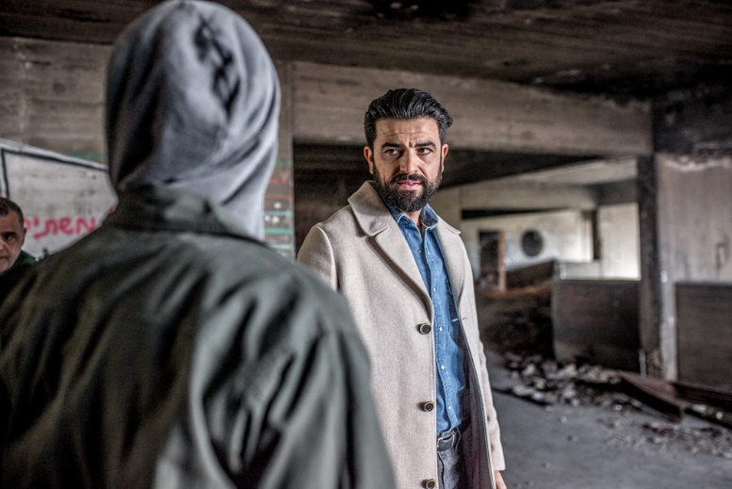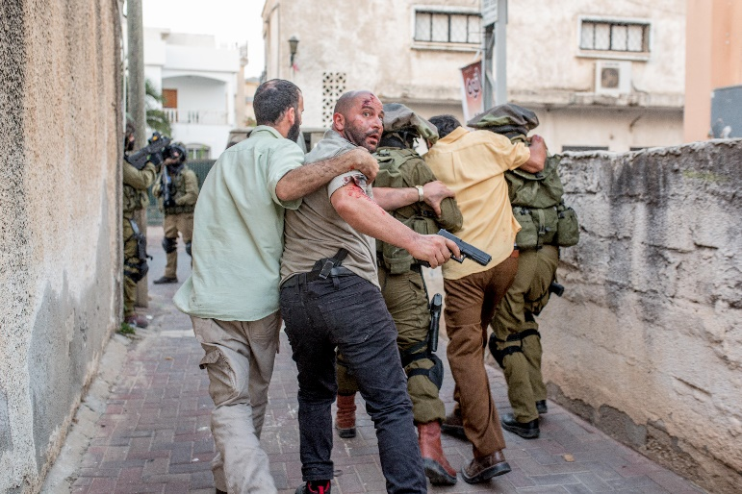

THE MAGPIE - New TV Series, Crime Drama directed by Ariel Benbaji

FAUDA – 3rd season directed by Rotem Shamir

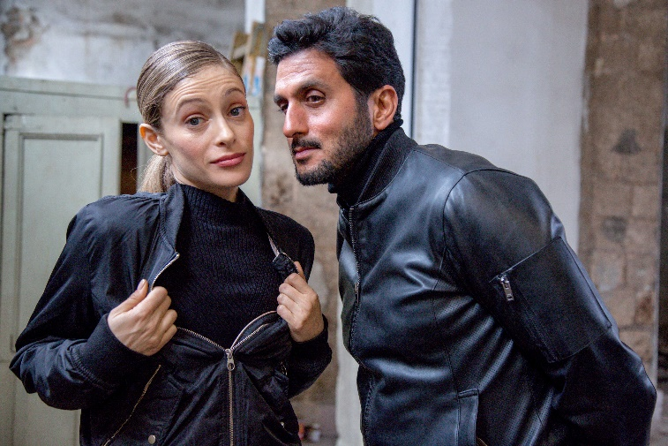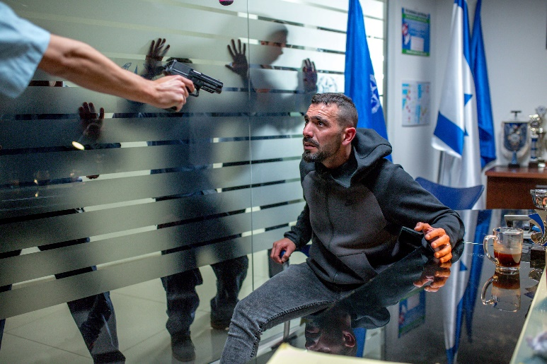

DO NOT WAIT FOR ME - Feature film, directed by Danni Reisfeld

HAMOSAD - Feature film, directed by Alon Gur Arie

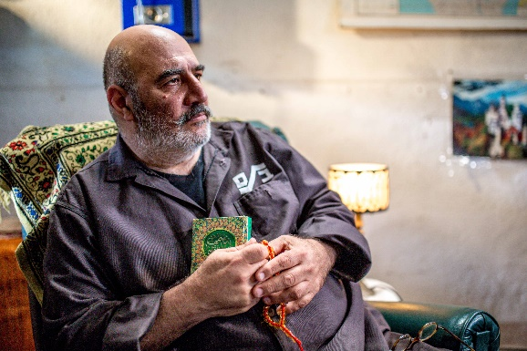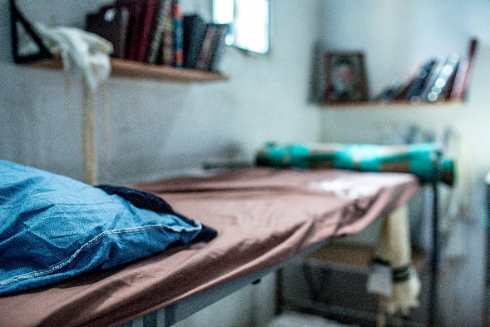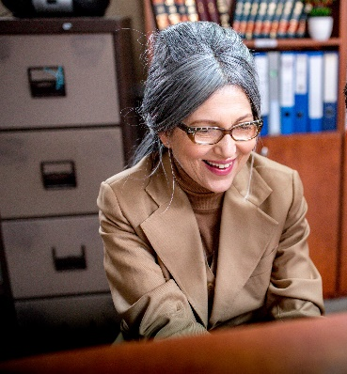

SHABAS - New TV Series

